Athens Certificate Update

- The server you’re working on should be taken out of the load balancer
  - This process will require an IIS restart
- Log in to the Service Provider Administration area
- Click on the Download link in the top navigation
- Under Configuration files and certificates
  - Click and download the following:
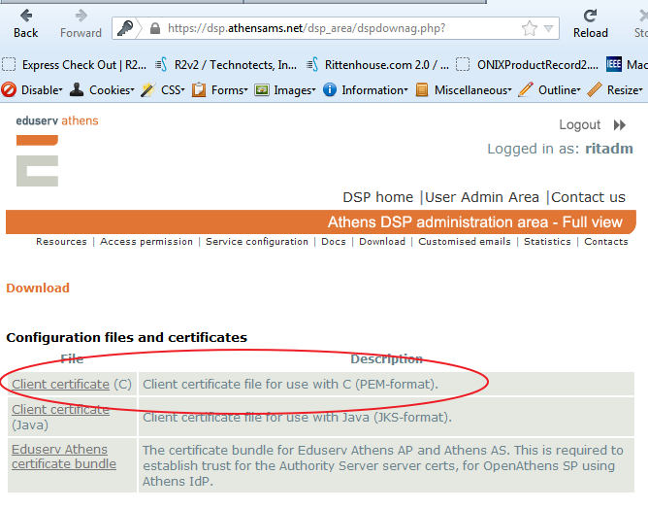
- Run the downloaded msi
- Save the Ritten.pem file to the following location:
  - “C:\Program Files (x86)\Eduserv\OpenAthens.Net\keys”
- Run an IIS restart
- Test to verify you are able to log through Athens.
  - Ritkenhaberle account should be suitable for this.
- Repeat this process for each server in the farm

Other Information (gathered by emails from Mike Malone)

Guys:

Below is some more Athens information … wkhadm is now OK from the technotects office.

For this we need to configure ritadm to be somewhat like what Brian did for LNPS. I’ve included some screenshot from the wkhadm area.
We need to get ritadm to work for dev / staging and production as well.

As I recall, there are issues getting this to work in development because they must call back to our server, etc.

Brian: Can we all have a call to discuss/review this at ~3pm? We have a call right before that but I’ll like to have a pow-wow to get ths rolling.

Thanks!
Mike

Username: Ritadm
Password: oliver1988

Open Athens Service Provider: https://sp.openathens.net/

Account Administration - https://admin.athens.ac.uk/index.php

Service Provider Administration - https://dsp.athensams.net/dsp_area

https://docs.openathens.net/display/public/OASP20/Using+OpenAthens+SP+with+ASP.NET+-+A+step-by-step+guide

1. SAML2 Metadata Configuration @ DSP Admin

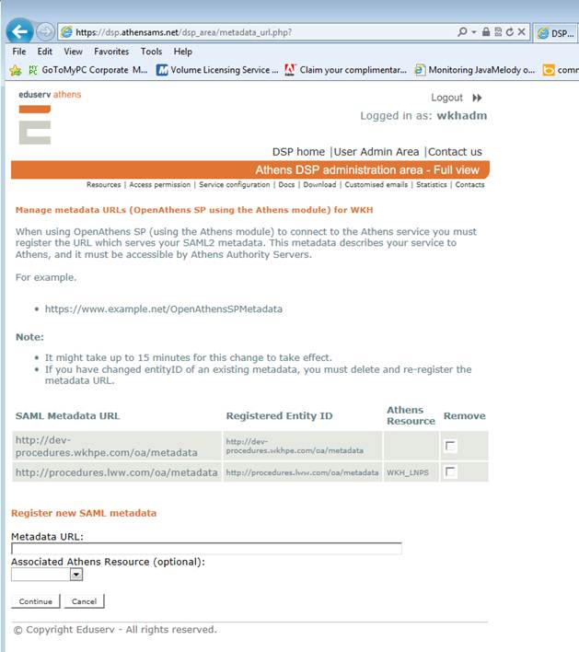

2. Certificate Bundle?

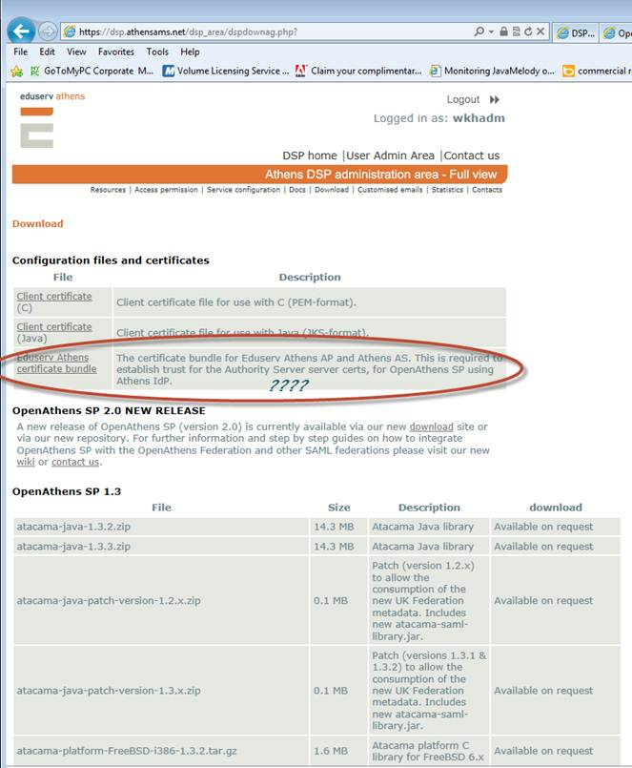

3. Open Athens Service Provider: https://sp.openathens.net/

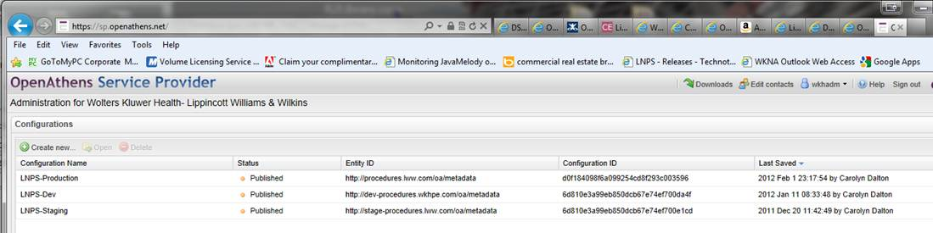

FOR DEV:

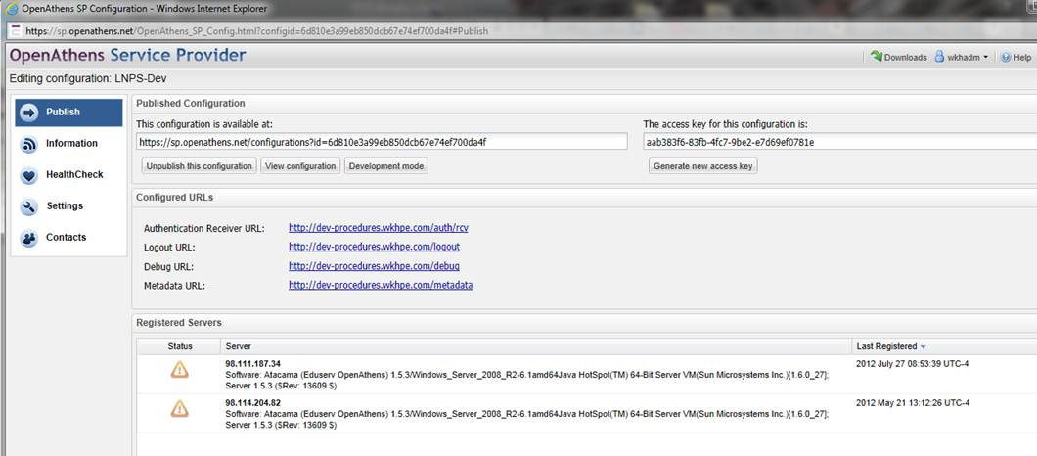

From: Mike Malone [mailto:MikeMalone@technotects.com]
Sent: Thursday, July 19, 2012 12:39 PM
To: MikeMalone@technotects.com; kenhaberle@technotects.com
Cc: BrianWright@technotects.com; Scott J. Scheider
Subject: R2v2 Athen SP 2 Implementation (updated)

OpenAthens SP Windows  OpenAthens SP Software client software for integration with Windows ASP.NET applications. | OpenAthens-SP2.msi (12.0 MB)  md5: 9feda87135c62068fc95b3589b064fa3

Athens 2.0 Documentation
https://docs.openathens.net/display/public/OASP20/OpenAthens+SP+Documentation+Home

Athens 2.0 - HealthCare
https://docs.openathens.net/display/public/OAHF/OpenAthens+Healthcare+Federation+Home

ATHENS INFO – MASTER LIST

Technotects Test Account

ritkenhaberle
Techno2008

Master Rittenhouse Athens Account

Username: Ritadm
Password: Hjdcvn2Wa

Account Administration - https://admin.athens.ac.uk/index.php

Service Provider Administration - https://dsp.athensams.net/dsp_area

R2 Library Athens Customer:
username – 040501
Password – ebooks

Midwestern University Examples

Midwestern University-Downers Grove 38447910 ahimudg
Midwestern University-Glendale, AZ 12620193 ahimuaz

Athens Org Ids setup for 040501: 12620193, 38447910

Arizona Examples

AthensID: ahi.erik.watkins
Password: erik123

AthensID: ahi.janecress
Password: jane234

Illinois Examples

AthensID: ahidg.rcaton
Password: ahi1234

AthensID: ahidg.hbravender
Password: brave123

